**WINDOW BLINDS MEASUREMENT SHEET**

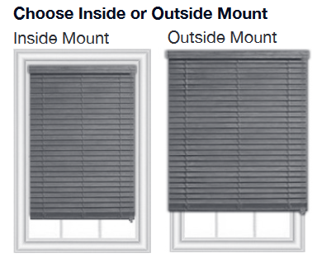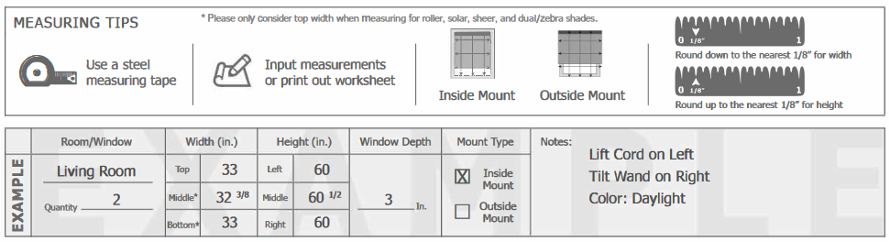

**Inside Mount:**

On an inside mount, the headrail will sit back in the window casing so that it will emphasize the actual size of the window and it allows your window molding to be visible. If you want your blind to fit flush with the window molding, you  
need to make sure you have enough depth in your window to accommodate the depth of the headrail. Even if you do not have the necessary depth for a flush mount, you can still do an inside  
mount and the blind will just project slightly out from the window molding.

**Outside Mount**:

Blinds mounted on the outside of the window  
frame provide the illusion of a longer and wider window and can help in hiding an unattractive window. The blind can be mounted either on the window molding itself or above and beyond the window molding. This option always provides for greater privacy and light control. An outside mountmay be your only option if the window is not deep enough to contain at least the blind mounting brackets.

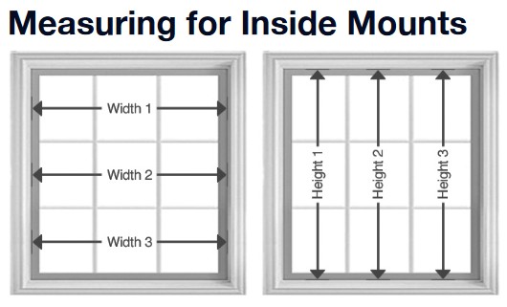

Measure the WIDTH of your window in three places – top, center and bottom. Use the smallest width measurement. Measure the exact HEIGHT of the window in three places. If you are measuring for vertical blinds, use the shortest height; otherwise use the longest height.

USE THE SMALLEST WIDTH MEASUREMENT.

USE THE LONGEST HEIGHT MEASUREMENT FOR A PERFECT FIT.



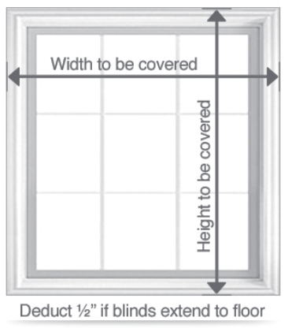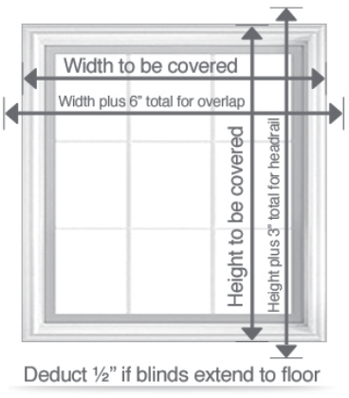

Measure the exact width from outer edge to outer edge of window molding. Make sure your dimensions include the frame itself. Measure the exact height from top outer edge of molding to bottom edge of sill, window molding or window crank (measure to where you would like the blind to end/ stop when fully closed). If ordering verticals extending to the floor deduct  
½” for clearance of the vanes.

**Mounting beyond the window molding:**  
Measure the exact width from outer edge to outer edge of window molding. Make sure your dimensions include the frame itself. If you prefer the blind/shade to appear larger or for optimum light control and privacy add up to 3” for overlap to each  
side. Measure the exact height from top outer edge of molding to bottom edge of sill, window molding or window crank measure to where you would like the blind to end/stop when fully closed) and add up to 3” for the top head rail to mount above the top window molding. If ordering verticals extending to the floor, deduct ½” for clearance of the vanes.

**ALWAYS USE A STANDARD STEEL MEASURING TAPE AND USE THE SAME MEASURING TAPE THROUGHOUT FOR A SET OF BLINDS**

|  |  |  |  |  |  |  |  |  |  |  |  |
| --- | --- | --- | --- | --- | --- | --- | --- | --- | --- | --- | --- |
| 1 | **Room/Window** | **Width (in mm)** | | **Height (in mm)** | | | **Mount Type** | | **Motorized** | | **Roundoff Size** |
|  | Top |  | Left |  | | Inside |  | Yes |  |  |
| Qty - | Mid |  | Mid |  | | Outside |  | No |  |
|  | Bottom |  | Right |  | |  |  |  |  |
|  | **Blind Shade No** | **String Operation Side** | | **Operation String Type** | | |  | | | |  |
|  | Left |  | Ladder | |  |
|  | Right |  | String | |  |
| 2 | **Room/Window** | **Width (in mm)** | | **Height (in mm)** | | | **Mount Type** | | **Motorized** | | **Roundoff Size** |
|  | Top |  | Left |  | | Inside |  | Yes |  |  |
| Qty - | Mid |  | Mid |  | | Outside |  | No |  |
|  | Bottom |  | Right |  | |  |  |  |  |
|  | **Blind Shade No** | **String Operation Side** | | **Operation String Type** | | |  | | | |  |
|  | Left |  | Ladder | |  |
|  | Right |  | String | |  |

|  |  |  |  |  |  |  |  |  |  |  |  |
| --- | --- | --- | --- | --- | --- | --- | --- | --- | --- | --- | --- |
| 3 | **Room/Window** | **Width (in mm)** | | **Height (in mm)** | | | **Mount Type** | | **Motorized** | | **Roundoff Size** |
|  | Top |  | Left |  | | Inside |  | Yes |  |  |
| Qty - | Mid |  | Mid |  | | Outside |  | No |  |
|  | Bottom |  | Right |  | |  |  |  |  |
|  | **Blind Shade No** | **String Operation Side** | | **Operation String Type** | | |  | | | |  |
|  | Left |  | Ladder | |  |
|  | Right |  | String | |  |

|  |  |  |  |  |  |  |  |  |  |  |  |
| --- | --- | --- | --- | --- | --- | --- | --- | --- | --- | --- | --- |
| 4 | **Room/Window** | **Width (in mm)** | | **Height (in mm)** | | | **Mount Type** | | **Motorized** | | **Roundoff Size** |
|  | Top |  | Left |  | | Inside |  | Yes |  |  |
| Qty - | Mid |  | Mid |  | | Outside |  | No |  |
|  | Bottom |  | Right |  | |  |  |  |  |
|  | **Blind Shade No** | **String Operation Side** | | **Operation String Type** | | |  | | | |  |
|  | Left |  | Ladder | |  |
|  | Right |  | String | |  |

|  |  |  |  |  |  |  |  |  |  |  |  |  |
| --- | --- | --- | --- | --- | --- | --- | --- | --- | --- | --- | --- | --- |
| 5 | **Room/Window** | **Width (in mm)** | | | **Height (in mm)** | | | **Mount Type** | | **Motorized** | | **Roundoff Size** |
|  | Top | |  | Left |  | | Inside |  | Yes |  |  |
| Qty - | Mid | |  | Mid |  | | Outside |  | No |  |
|  | Bottom | |  | Right |  | |  |  |  |  |
|  | **Blind Shade No** | **String Operation Side** | | | **Operation String Type** | | |  | | | |  |
|  | Left |  | | Ladder | |  |
|  | Right |  | | String | |  |

|  |  |  |  |  |  |  |  |  |  |  |  |
| --- | --- | --- | --- | --- | --- | --- | --- | --- | --- | --- | --- |
| 6 | **Room/Window** | **Width (in mm)** | | **Height (in mm)** | | | **Mount Type** | | **Motorized** | | **Roundoff Size** |
|  | Top |  | Left |  | | Inside |  | Yes |  |  |
| Qty - | Mid |  | Mid |  | | Outside |  | No |  |
|  | Bottom |  | Right |  | |  |  |  |  |
|  | **Blind Shade No** | **String Operation Side** | | **Operation String Type** | | |  | | | |  |
|  | Left |  | Ladder | |  |
|  | Right |  | String | |  |

|  |  |  |  |  |  |  |  |  |  |  |  |  |
| --- | --- | --- | --- | --- | --- | --- | --- | --- | --- | --- | --- | --- |
| 7 | **Room/Window** | **Width (in mm)** | | | **Height (in mm)** | | | **Mount Type** | | **Motorized** | | **Roundoff Size** |
|  | Top | |  | Left |  | | Inside |  | Yes |  |  |
| Qty - | Mid | |  | Mid |  | | Outside |  | No |  |
|  | Bottom | |  | Right |  | |  |  |  |  |
|  | **Blind Shade No** | **String Operation Side** | | | **Operation String Type** | | |  | | | |  |
|  | Left |  | | Ladder | |  |
|  | Right |  | | String | |  |

|  |  |  |  |  |  |  |  |  |  |  |  |
| --- | --- | --- | --- | --- | --- | --- | --- | --- | --- | --- | --- |
| 8 | **Room/Window** | **Width (in mm)** | | **Height (in mm)** | | | **Mount Type** | | **Motorized** | | **Roundoff Size** |
|  | Top |  | Left |  | | Inside |  | Yes |  |  |
| Qty - | Mid |  | Mid |  | | Outside |  | No |  |
|  | Bottom |  | Right |  | |  |  |  |  |
|  | **Blind Shade No** | **String Operation Side** | | **Operation String Type** | | |  | | | |  |
|  | Left |  | Ladder | |  |
|  | Right |  | String | |  |

|  |  |  |  |  |  |  |  |  |  |  |  |
| --- | --- | --- | --- | --- | --- | --- | --- | --- | --- | --- | --- |
| 9 | **Room/Window** | **Width (in mm)** | | **Height (in mm)** | | | **Mount Type** | | **Motorized** | | **Roundoff Size** |
|  | Top |  | Left |  | | Inside |  | Yes |  |  |
| Qty - | Mid |  | Mid |  | | Outside |  | No |  |
|  | Bottom |  | Right |  | |  |  |  |  |
|  | **Blind Shade No** | **String Operation Side** | | **Operation String Type** | | |  | | | |  |
|  | Left |  | Ladder | |  |
|  | Right |  | String | |  |

|  |  |  |  |  |  |  |  |  |  |  |  |
| --- | --- | --- | --- | --- | --- | --- | --- | --- | --- | --- | --- |
| 10 | **Room/Window** | **Width (in mm)** | | **Height (in mm)** | | | **Mount Type** | | **Motorized** | | **Roundoff Size** |
|  | Top |  | Left |  | | Inside |  | Yes |  |  |
| Qty - | Mid |  | Mid |  | | Outside |  | No |  |
|  | Bottom |  | Right |  | |  |  |  |  |
|  | **Blind Shade No** | **String Operation Side** | | **Operation String Type** | | |  | | | |  |
|  | Left |  | Ladder | |  |
|  | Right |  | String | |  |

|  |  |  |  |  |  |  |  |  |  |  |  |
| --- | --- | --- | --- | --- | --- | --- | --- | --- | --- | --- | --- |
| 11 | **Room/Window** | **Width (in mm)** | | **Height (in mm)** | | | **Mount Type** | | **Motorized** | | **Roundoff Size** |
|  | Top |  | Left |  | | Inside |  | Yes |  |  |
| Qty - | Mid |  | Mid |  | | Outside |  | No |  |
|  | Bottom |  | Right |  | |  |  |  |  |
|  | **Blind Shade No** | **String Operation Side** | | **Operation String Type** | | |  | | | |  |
|  | Left |  | Ladder | |  |
|  | Right |  | String | |  |